Letter of Invitation

May XXX, 2023
Dear Sir or Madam:

On behalf of the Organizing Committee of the 1st International Biopetrological Congress, I feel greatly honored and pleased to extend our gracious invitation to Prof. ___________——____ (Gender:_______; Nationality:______________; Date of Birth: _______; Passport number:____________; Occupation:__________) from University of ________________ to attend the 1st International Biopetrological Congress that will be held in Shijiazhuang, China on September 17-21, 2023. He/She is an internationally famous expert in biopetrology, and is invited to give a plenary oral presentation and host a session in the congress. His presence is crucial to the success of the conference.

During his stay in Shijiazhuang, he will be accommodated in Ximeiwuzhou Hotel (145 Huaiandonglu Road, Yuhua District, Shijaizhuang, Hebei Province, China). All the expenses will be covered by the congress.

If there is any question, please feel free to contact our office by email biopetrology@qq.com or by phone 13241929326.

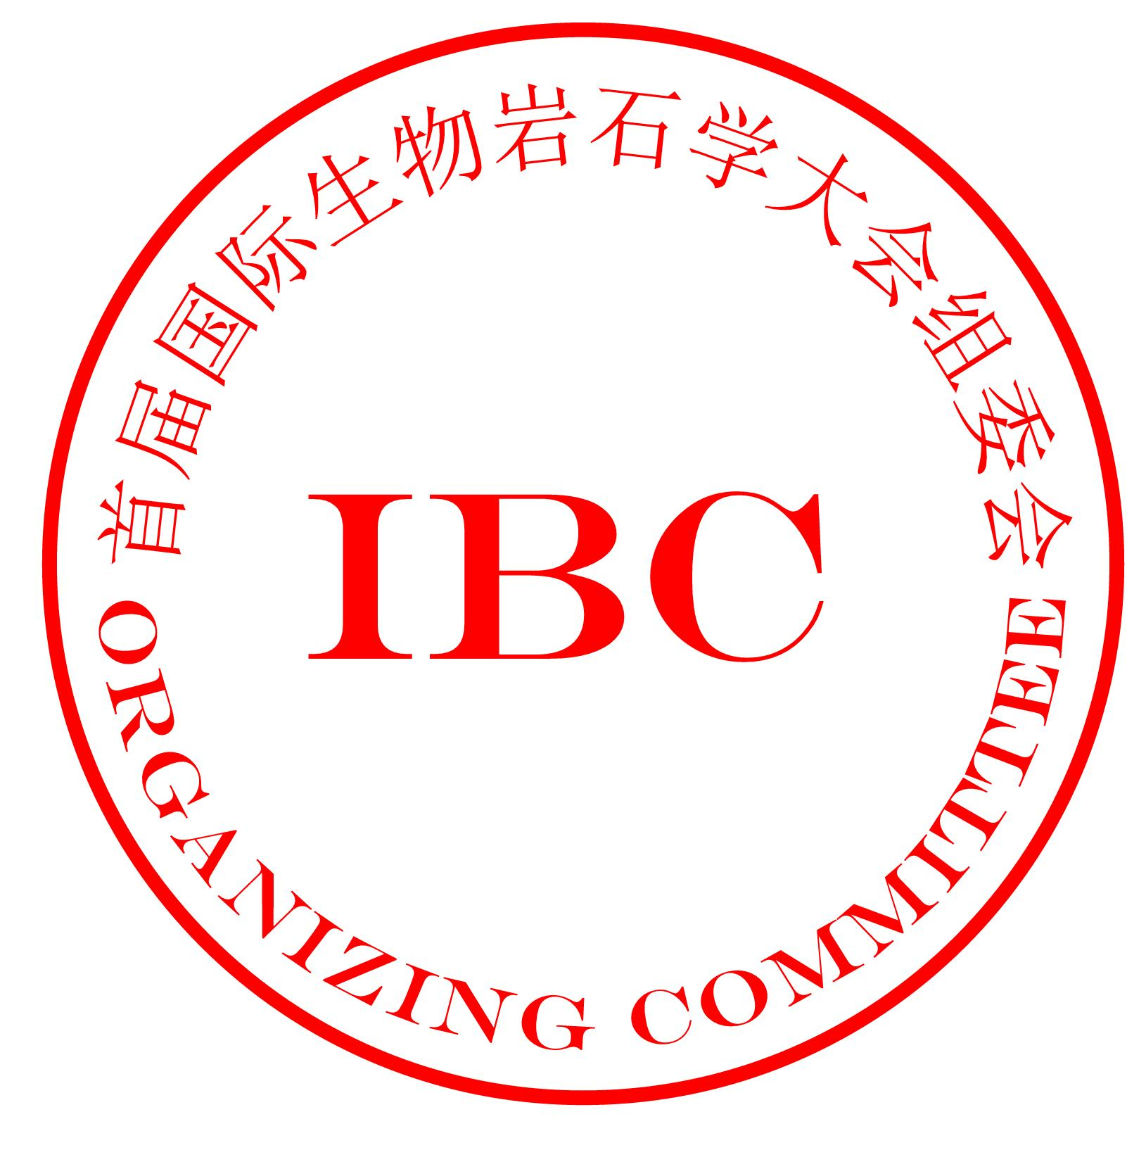
Thank you.
Yours sincerely,

—by the Organizing Committee of the 1st
International Biopetrological Congress

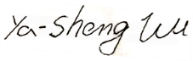
—by Ya-Sheng Wu, Chair of the Organizing Committee of
the 1st International Biopetrological Congress

