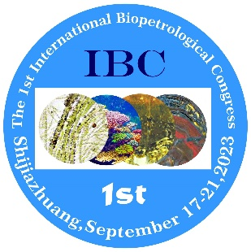
Invitation

Dear Prof./Dr. __________,
Sponsored by the International Biopetrological Association (IBA), and organized by 14 universities and research institutions, the 1st International Bioptrological Congress will be held in Shijiazhuang, China, on September 17-21, 2023.
The congress aims to be a platform for global scientists in biopetrology and the related disciplines to present and exchange their recent research results, and discuss how to promote the development of the disciplines.
Shijiazhuang is selected as the venue of the congress not only because there are well-exposed Proterozoic and Cambrian microbialite profiles near it, but also because it is not far from Beijing and Jixian of Tianjin, where the worldwide famous Great Wall and the best and longest Mesoproterozoic sequences are exposed.
In this congress, more than 22 topics involving bioliths and evolution of Earth system will be discussed in 13 sessions and 15 invited plenary presentations.
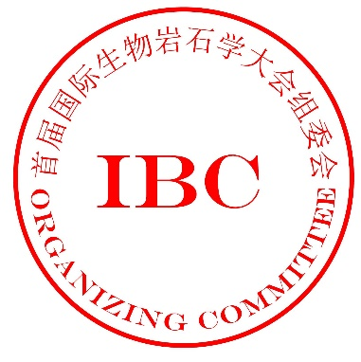
The congress will be a milestone event in the development of biopetrology. It is a great chance for you to witness the historical event and present your innovative research results. Here, on behalf of the Organizing Committee of the congress, I am having the honor to invite you to attend the congress, give oral presentations or posters, and visit the precious and exquisite microbialite outcrops.
——by The Organizing Committee of The 1st International Biopetrological Congress
——by Chair of IBA and IBC

On January 11, 2023

